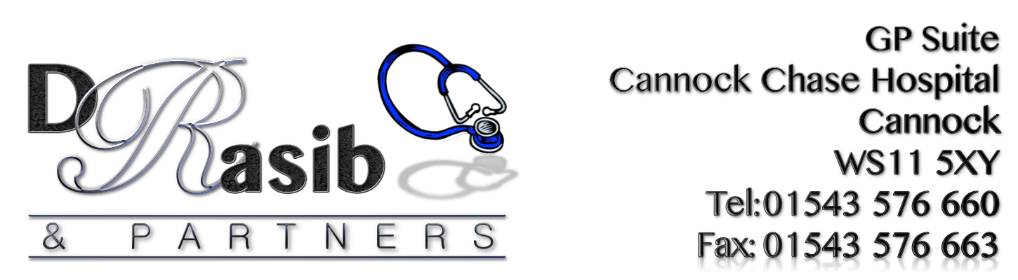

NewsLetter
Spring 2018: Edition 7

PLEASE CANCEL YOUR
APPOINTMENT IF YOU DON’T NEED IT ANY LONGER

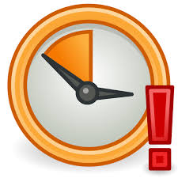
DID NOT ATTEND APPOINTMENTS

Only you can help to reduce our DNA numbers. Please let us know as soon as possible if you no longer require or cannot make your appointments as last minute cancellations are wasted appointments So next time you are unable to get a GP appointment as quickly as you would like, think about all the missed appointments.

‘S

OR

Appointment no show
IMPORTANT! PLEASE, PLEASE, PLEASE
!!!Always cancel appointments you no longer require!!!
CURE

‘Get the right care, at the right time,
at the right place’ without delay.
The point of care navigation is to help patients
‘Get the right care, at the right time, at the right place’ without delay.

How does it work?

- Patients contacting the surgery will be asked for further information regarding their problem.
- Patients will be ‘signposted’ to a member of a multi-skilled team best suited to deal with their problem.
- The patient will be treated, or at least seen by a healthcare professional the same day.
- Surgery staff have received training and will be monitored to ensure patients are handled in the correct way.

Care navigators are receptionists and admin staff but through specialist training, they also possess additional skills and provide a crucial practice role in improving access to primary care. All with the aim of helping patients to get to the right service faster.

Keep Active and Stay Healthy
Physical activity keeps you healthy,
improves sleep, helps you maintain a
healthy weight, reduces stress and improves
overall quality of life. In fact, the risk of conditions
like diabetes, heart disease, depression,
dementia and cancer are all reduced (by 20-40%)
by keeping active.

For a healthy heart and mind, try vigorous activity like running, sport or climbing stairs, or moderate activity involves things like walking, cycling and swimming. Aim to do about 75 minutes of vigorous activity, or 150 minutes of moderate activity or a combination of both.

Spend less time sitting around, so watching TV, sitting on the sofa and in front of the computer should all be reduced, and make sure you have regular breaks from sitting too long.
Build muscle strength and keep bones and joints strong by going to a gym, practising yoga, or carrying bags and improve overall balance to reduce the risk of falls by dancing, going to bowls or doing tai chi.
Try these things at least twice a week. At the end of the day, something is better than nothing; start off small and build up gradually, and even 10 minutes at a time will provide some benefit. It’s never too late to start, so start today!

Visit the government’s Start Active, Stay Active site at bit.ly/startactive

NEW & UPCOMING SERVICES AT THE PRACTICE
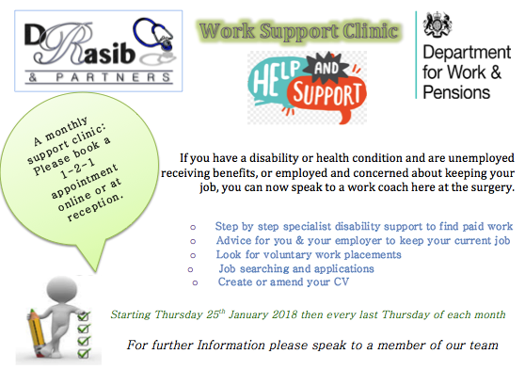
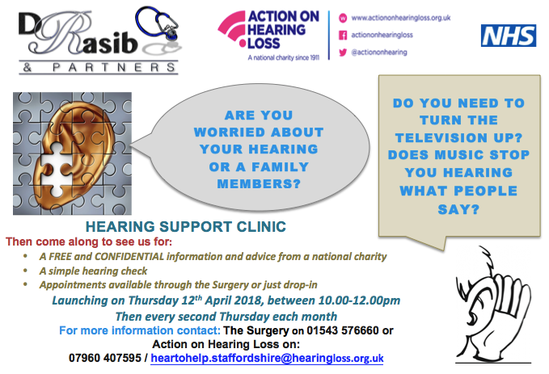

Pharmacist Practitioner  Dave is a qualified pharmacist prescriber. This means that the practice is able to offer patients more options and availability to see a practitioner other than a GP. Dave is able to see patients for a variety of ailments and assist them in treatment options, provide healthcare advice and even refer to specialists.  PATIENT QUESTIONNAIRES  Thank you to all patients who gave their time and participated.  The results for these questionnaires will be published by June 2018  PATIENT BUDDY SCHEME  We are welcoming more patients to join the scheme. You shall be well supported and also be giving support to a needy patient.  Please ask at reception for further details and an application form  LEAFLET REQUIRED IN A DIFFERENT FORMAT?  If you require this leaflet in any other format then please do not hesitate to speak to a member of the team.  PATIENT COMMENTS/SUGGESTIONS  If you have any comments or suggestions about this newsletter or indeed any aspect of the service that Dr Rasib & Partners provides, please feel free to contact the Managing Partner, Sam Rasib on 01543 576660 or in writing to GP Suite, Cannock Chase Hospital, Brunswick Road, WS11 5XY | Emergency & OOH Cover  EMERGENCIES  In the event of a serious problem, such as chest pain or collapse, call 999 immediately.  OUT-OF-HOURS COVER  Medical advice is always available for emergencies at night, weekends and  all bank holidays.  NHS 111  For urgent  & non-urgent advice call 111.  You can also ring  01543 576660  Where the recorded message will give you the number for the Out-of-Hours service  STOP PRESS!  DO NOT FORGET THAT WE OFFER TELEPHONE CONSULTATIONS  Thursday evenings  6.30-7.30pm

